Assignment
Fundamental Theory
(LAB: 3)
NAME: Majid Ali
CMS ID: 053-25-0017
PROGRAM: Software engineering (Section: A)

Question 1:
Write a program that generates the following output by using setw, left, right and endl manipulators.
#include<iostream>
#include<iomanip>
using namespace std;
int main(){
cout<<left<<setw(5)<<"Programming"<<endl;
cout<<right<<setw(20)<<"Fundamentals"<<endl;
cout<<right<<setw(18)<<"C++"<<endl;
return 0;
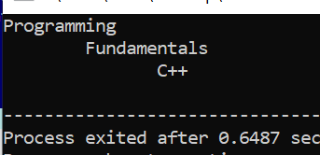
}

Question 2:
Write a program to print the following shapes using the setw and endl manipulator only (Don’t use escape sequence or spaces).
Hint: setw only affects the immediately following output. It doesn't persist for subsequent outputs.
a.
#include<iostream>
#include<iomanip>
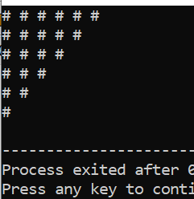
using namespace std;
int main(){
cout<<setw(1)<<"#"<<setw(2)<<"#"<<setw(2)<<"#"<<setw(2)<<"#"<<setw(2)<<"#"<<setw(2)<<"#"<<endl;
cout<<setw(1)<<"#"<<setw(2)<<"#"<<setw(2)<<"#"<<setw(2)<<"#"<<setw(2)<<"#"<<endl;
cout<<setw(1)<<"#"<<setw(2)<<"#"<<setw(2)<<"#"<<setw(2)<<"#"<<endl;
cout<<setw(1)<<"#"<<setw(2)<<"#"<<setw(2)<<"#"<<setw(2)<<endl;
cout<<setw(1)<<"#"<<setw(2)<<"#"<<setw(2)<<endl;
cout<<setw(1)<<"#"<<endl;
return 0;
}
b.
#include<iostream>
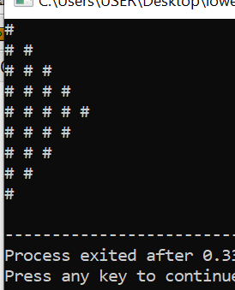
#include<iomanip>
using namespace std;
int main(){
cout<<setw(1)<<"#"<<endl;
cout<<setw(1)<<"#"<<setw(2)<<"#"<<setw(2)<<endl;
cout<<setw(1)<<"#"<<setw(2)<<"#"<<setw(2)<<"#"<<setw(2)<<endl;
cout<<setw(1)<<"#"<<setw(2)<<"#"<<setw(2)<<"#"<<setw(2)<<"#"<<endl;
cout<<setw(1)<<"#"<<setw(2)<<"#"<<setw(2)<<"#"<<setw(2)<<"#"<<setw(2)<<"#"<<endl;
cout<<setw(1)<<"#"<<setw(2)<<"#"<<setw(2)<<"#"<<setw(2)<<"#"<<endl;
cout<<setw(1)<<"#"<<setw(2)<<"#"<<setw(2)<<"#"<<setw(2)<<endl;
cout<<setw(1)<<"#"<<setw(2)<<"#"<<setw(2)<<endl;
cout<<setw(1)<<"#"<<endl;
return 0;
}
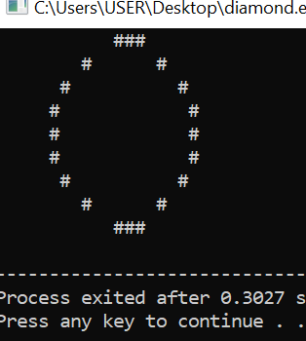
c.
#include<iostream>
#include<iomanip>
using namespace std;
int main(){
cout<<setw(14)<<"###"<<endl;
cout<<setw(9)<<"#"<<setw(7)<<"#"<<endl;
cout<<setw(7)<<"#"<<setw(11)<<"#"<<endl;
cout<<setw(6)<<"#"<<setw(13)<<"#"<<endl;
cout<<setw(6)<<"#"<<setw(13)<<"#"<<endl;
cout<<setw(6)<<"#"<<setw(13)<<"#"<<endl;
cout<<setw(7)<<"#"<<setw(11)<<"#"<<endl;
cout<<setw(9)<<"#"<<setw(7)<<"#"<<endl;
cout<<setw(14)<<"###"<<endl;
return 0;
}
d.
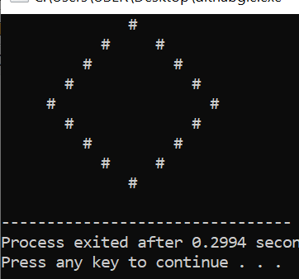
#include<iostream>
#include<iomanip>
using namespace std;
int main(){
cout<<setw(15)<<"#"<<endl;
cout<<setw(12)<<"#"<<setw(6)<<"#"<<endl;
cout<<setw(10)<<"#"<<setw(10)<<"#"<<endl;
cout<<setw(8)<<"#"<<setw(14)<<"#"<<endl;
cout<<setw(6)<<"#"<<setw(18)<<"#"<<endl;
cout<<setw(8)<<"#"<<setw(14)<<"#"<<endl;
cout<<setw(10)<<"#"<<setw(10)<<"#"<<endl;
cout<<setw(12)<<"#"<<setw(6)<<"#"<<endl;
cout<<setw(15)<<"#"<<endl;
}
Question 3:
Write a program that asks the user to input two numbers i.e., num1 and num2; And the output should be formatted according to these numbers. The larger number will print the larger gap on the screen (use setw and right align).
#include<iostream>
#include<iomanip>
using namespace std;
int main(){
int num1;
int num2;
cout<<setw(1)<<"Enter 1st value:"<<setw(2)<<"";
cin>>num1;
cout<<setw(1)<<"Enter 2nd value:"<<setw(2)<<"";
cin>>num2;
cout<<setw(10)<<num1<<setw(7)<<"slots"<<endl;
cout<<setw(26)<<num2<<setw(7)<<"slots"<<endl;
return 0;
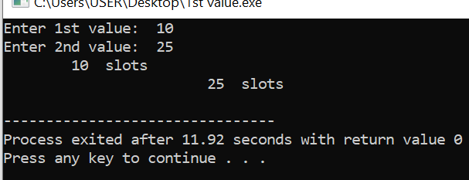
}

Question 4:
Generate the below-mentioned output using the Manipulators only (setw(n), endl, fixed, left, etc.) Hint: You may use setprecision(n), left/right, and fixed only once in a program. No need to use them again and again.
#include<iostream>
#include<iomanip>
using namespace std;
int main(){
cout<<setw(54)<<setfill('=')<<" "<<endl;
cout<<setfill(' ')<<setw(22)<<"HYPER MALL"<<endl;
cout<<setw(54)<<setfill('=')<<" "<<endl;
cout<<setfill(' ')<<right<<setw(1)<<"Items"<<setw(11)<<"Small"<<setw(13)<<"Medium"<<setw(14)<<"Large"<<endl;
cout<<right<<setfill(' ')<<setw(1)<<"Box"<<setw(13)<<fixed<<setprecision(2)<<20.5869<<setw(12)<<setprecision(2)<<40.5923<<setw(15)<<setprecision(2)<<60.7534<<endl;
cout<<right<<setfill(' ')<<setw(1)<<"Bottle"<<setw(10)<<fixed<<setprecision(2)<<18.5921<<setw(12)<<setprecision(2)<<29.8423<<setw(15)<<setprecision(2)<<35.7514<<endl;
cout<<right<<setfill('')<<setw(1)<<"Socks"<<setw(11)<<fixed<<setprecision(2)<<20.5032<<setw(12)<<setprecision(2)<<50.59321<<setw(15)<<
setprecision(2)<<99.75413<<endl;
cout<<right<<setfill(' ')<<setw(1)<<"Beg"<<setw(13)<<fixed<<setprecision(2)<<89.8712<<setw(12)<<setprecision(2)<<92.8732<<setw(15)<<setprecision(2)<<99.89321<<endl;
cout<<right<<setfill(' ')<<setw(1)<<"Glass"<<setw(11)<<fixed<<setprecision(2)<<70.503432<<setw(12)<<setprecision(2)<<80.593421<<setw(15)<<setprecision(2)<<90.75412<<endl;
cout<<right<<setfill(' ')<<setw(1)<<"Ball"<<setw(12)<<fixed<<setprecision(2)<<67.893214<<setw(12)<<setprecision(2)<<78.973212<<setw(15)<<setprecision(2)<<98.653214<<endl;
cout<<right<<setfill(' ')<<setw(1)<<"Diary"<<setw(11)<<fixed<<setprecision(2)<<50.783212<<setw(12)<<setprecision(2)<<60.503241<<setw(15)<<setprecision(2)<<78.45332211<<endl;
return 0;
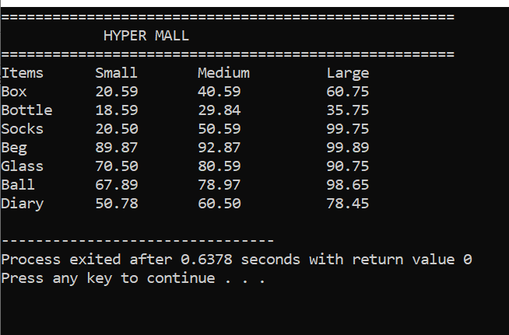
}

Question 5:
Write a program in which you create three float variables to set the price of 240.99999 for a joystick, 180.88888 for disk, and 570.77777 for keyboard. Your task is to print the prices of the above-mentioned items in the following format. NOTE: After decimal points, your program must print two digits.
#include<iostream>
#include<iomanip>
using namespace std;
int main(){
cout<<setw(51)<<setfill('=')<<" "<<endl;
cout<<setfill(' ')<<right<<setw(31)<<"TECHNO ELECTRONICS"<<endl;
cout<<setw(51)<<setfill('=')<<" "<<endl;
cout<<setfill(' ')<<setw(20)<<"Joystick"<<setw(3)<<":"<<setw(8)<<fixed<<setprecision(2)<<240.99999<<endl;
cout<<setfill(' ')<<setw(16)<<"Disk"<<setw(7)<<":"<<setw(8)<<fixed<<setprecision(2)<<180.888888<<endl;
cout<<setfill(' ')<<setw(20)<<"Keyboard"<<setw(3)<<":"<<setw(8)<<fixed<<setprecision(2)<<570.77777<<endl;
return 0;
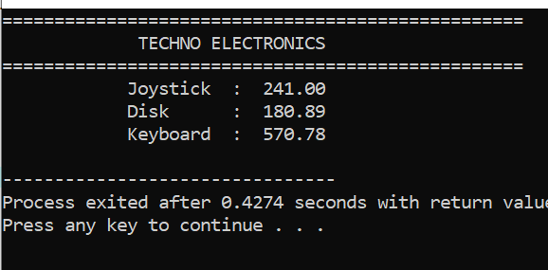
}

Q 6

Question 6:
Write a program for the marksheet, where user should be able to enter the marks for five subjects. Then, your program should tell him/her his/her obtained marks, average marks and percentage. Note: You can assume each subject to be of 100 marks. So, the total marks would become 500 for five subjects. While printing the final Marksheet it must contain your name and CMS-ID as student name and CMS-ID. The sample output is shown below (This is just a sample; you may even come up with new ideas to make marksheet look more eye-catching)
#include<iostream>
#include<iomanip>
using namespace std;
int main(){
float FP,ICT,OOP,Maths,English;
cout<<"enter the marks of FP: ";
cin>>FP;
cout<<"Enter the marks of ICT: ";
cin>>ICT;
cout<<"Enter the marks of OOP: ";
cin>>OOP;
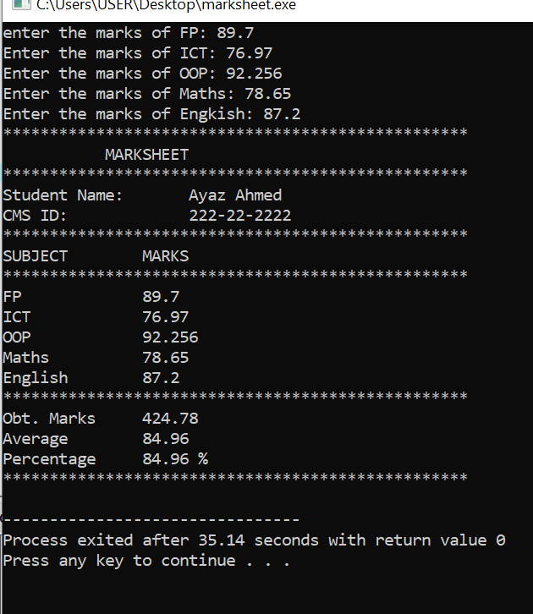
cout<<"Enter the marks of Maths: ";
cin>>Maths;
cout<<"Enter the marks of Engkish: ";
cin>>English;
cout<<setw(51)<<setfill('*')<<" "<<endl;
cout<<setfill(' ')<<setw(20)<<"MARKSHEET"<<endl;
cout<<setw(51)<<setfill('*')<<" "<<endl;
cout<<setw(1)<<"Student Name:"<<setw(17)<<setfill(' ')<<"Ayaz Ahmed"<<endl;
cout<<setw(1)<<"CMS ID:"<<setw(24)<<setfill(' ')<<"222-22-2222"<<endl;
cout<<setw(51)<<setfill('*')<<" "<<endl;
cout<<setw(1)<<"SUBJECT"<<setw(13)<<setfill(' ')<<"MARKS"<<endl;
cout<<setw(51)<<setfill('*')<<setfill(' ')<<" "<<endl;
cout<<setw(1)<<"FP"<<setw(17)<<setfill(' ')<<FP<<endl;
cout<<setw(1)<<"ICT"<<setw(17)<<setfill(' ')<<ICT<<endl;
cout<<setw(1)<<"OOP"<<setw(18)<<setfill(' ')<<OOP<<endl;
cout<<setw(1)<<"Maths"<<setw(15)<<setfill(' ')<<Maths<<endl;
cout<<setw(1)<<"English"<<setw(12)<<setfill(' ')<<English<<endl;
float obtainmarks=FP+ICT+OOP+Maths+English;
float Average=obtainmarks/5;
float percentage=obtainmarks/500*100;
cout<<setw(51)<<setfill('*')<<" "<<endl;
cout<<setw(1)<<"Obt. Marks"<<setw(11)<<setfill(' ')<<fixed<<setprecision(2)<<obtainmarks<<endl;
cout<<setw(1)<<"Average"<<setw(13)<<setfill(' ')<<fixed<<setprecision(2)<<Average<<endl;
cout<<setw(1)<<"Percentage"<<setw(10)<<setfill(' ')<<fixed<<setprecision(2)<<percentage<<" %"<<endl;
cout<<setw(51)<<setfill('*')<<" "<<endl;
return 0;
}

